**Step 1: Select Your Gateway**

1. In the left navigation pane, click **Gateways**.
2. Locate the gateway you want to update.
3. Click on the **gateway name** to open its settings.

**Step 2: Modify Maintenance Settings**

1. Click the **Actions** dropdown button.
2. Select **Edit maintenance settings**.

**Step 3: Enable or Disable Updates**

1. Under **Maintenance updates**, choose:
   * **On** (to allow automatic updates).
   * **Off** (to disable automatic updates).

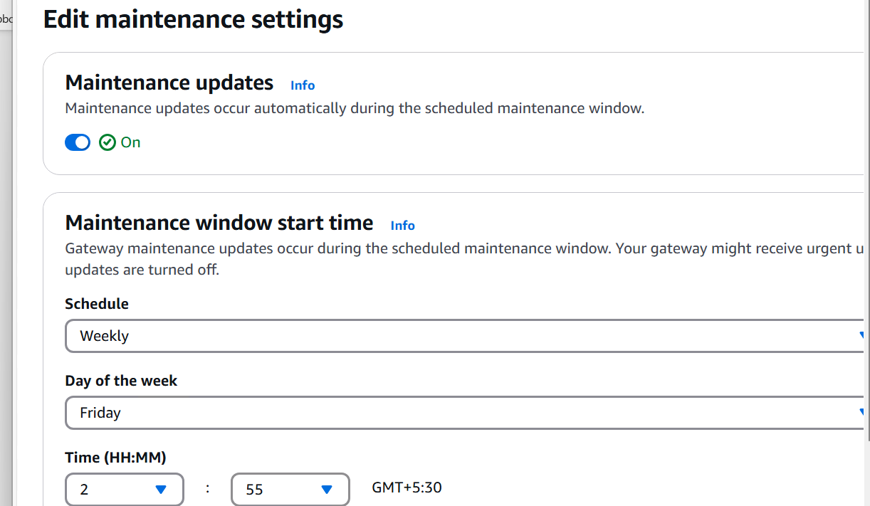

**Manual setup**

**Step 1: Select Your Gateway**

1. In the left navigation pane, click **Gateways**.
2. Locate and select the **gateway** you want to update.

* If an update is available, you will see a **blue notification banner** on the **Details** tab, indicating the update option.

**Step 3: Apply the Software Update**

1. Click **Apply update now** to start the update process.